COVID-19 Case Prediction
MITx Project

Project No: 26
Title: COVID-19 Case Prediction using SVM
Dataset: Latest COVID-19 India Status (Kaggle)
Algorithm: Support Vector Machine (SVM)
Student Name:
- Afreen Imam(23DS01)
- Tasmiya Fatma (23DS20)

1. Aim
The aim of this project is to predict the number of active COVID-19 cases using Support Vector Machine (SVM). By analyzing historical COVID-19 data, we aim to build a predictive model that can help in understanding future trends of active cases and assist healthcare authorities in planning and resource allocation.

2. Description

Case Study
The COVID-19 pandemic has posed significant challenges worldwide, and predicting active cases can help in better decision-making. This project uses machine learning techniques to analyze the dataset and predict future active cases.

Features of the Dataset:
- Total Cases: Total reported cases in a region.
- Active Cases: The number of currently active cases.
- Discharged: Number of recovered patients.
- Deaths: Number of COVID-19-related fatalities.
- Population: Population of the region.
- Cases per Million: The ratio of total cases to the population.
- Growth Rate: The percentage change in cases over time.
- 7-Day Averages: Moving averages for cases and deaths to smooth fluctuations.
- Lag Features: Previous day and weekly case counts.

Output Required:
The desired outcome of the project is:
- Prediction Model: Predict future active cases using SVM.
- Performance Evaluation: Evaluate model performance using R2 score, Mean Squared Error (MSE), and accuracy within a 5% error margin.
- Visualizations:
  - Scatter plot of actual vs predicted active cases.
  - Residual plot to analyze errors.
- Insights: Identify trends and anomalies in COVID-19 case progression.

3. Steps Followed:

1. Data Preprocessing:
- Handled missing values by filling them with zero.
- Created new features like cases per million, growth rate, and moving averages.
- Applied log transformation to deal with skewed data.

2. Feature Selection:
- Used SelectKBest with f_regression to select the top 10 features for the model.

3. Data Splitting:
- Split the dataset into training (80%) and testing (20%) sets.

4. Standardization:
- Applied StandardScaler to normalize features for better SVM performance.

5. Model Training:
- Used SVR (Support Vector Regression) to build the predictive model.
- Applied GridSearchCV for hyperparameter tuning.

6. Model Evaluation:
- Calculated R2 Score and Mean Squared Error (MSE).
- Measured accuracy based on predictions within a 5% error margin.

7. Visualization:
- Scatter plot of actual vs predicted values.
- Residual plot to examine model errors.

4. Expected Output:
Best Hyperparameters: Selected optimal values for SVM parameters.
R2 Score: Indicator of model performance.
MSE: Measures error in prediction.
Accuracy: Percentage of predictions within 5% of actual values.
Visual Plots: Graphical representation of model results.

5. Implementation:
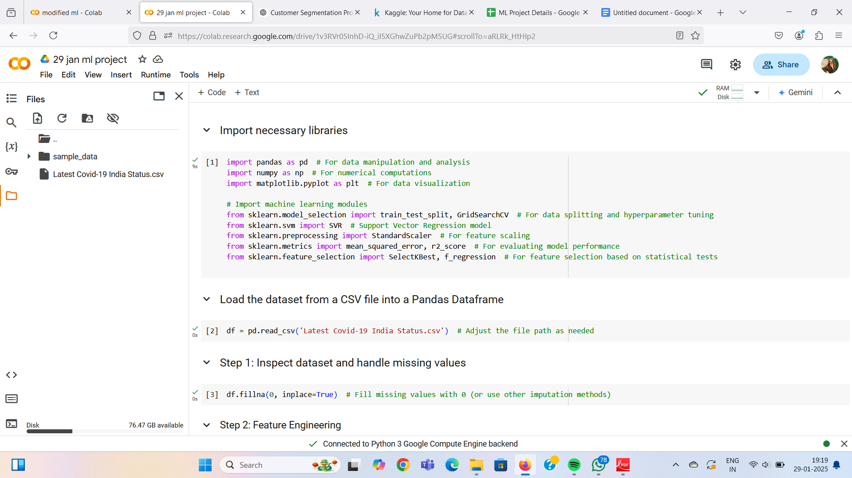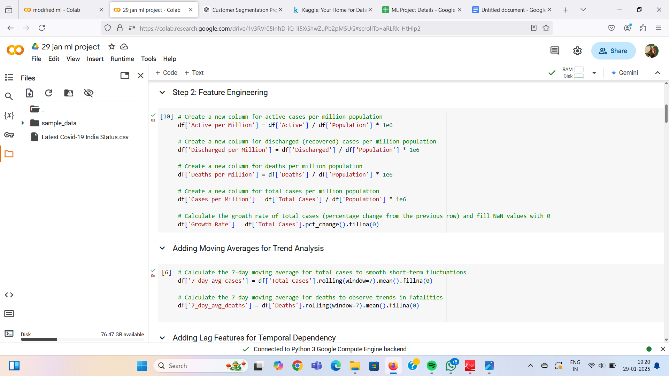

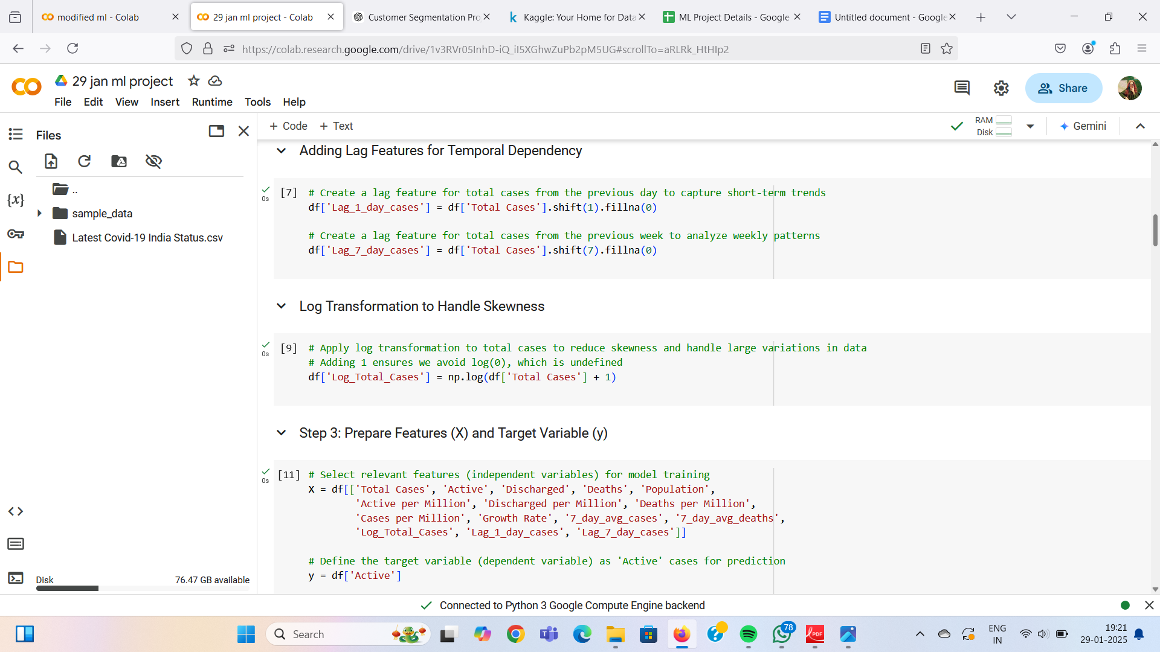
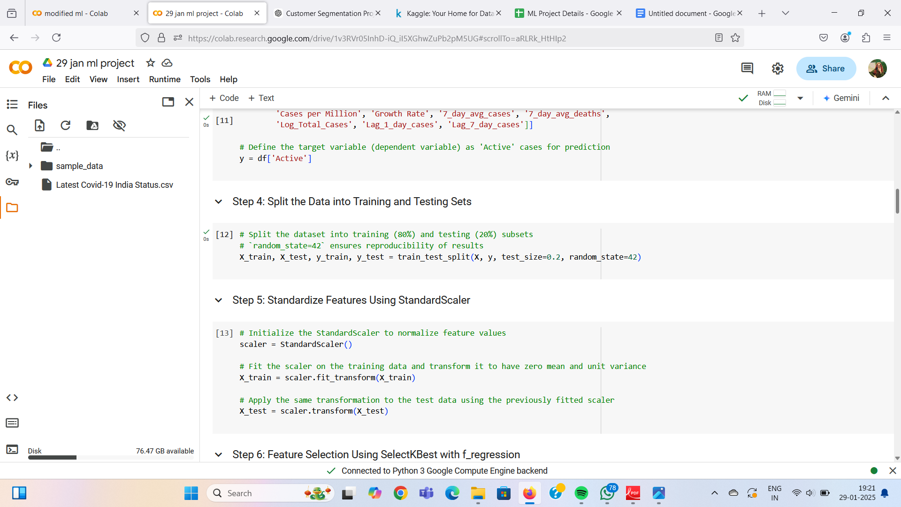

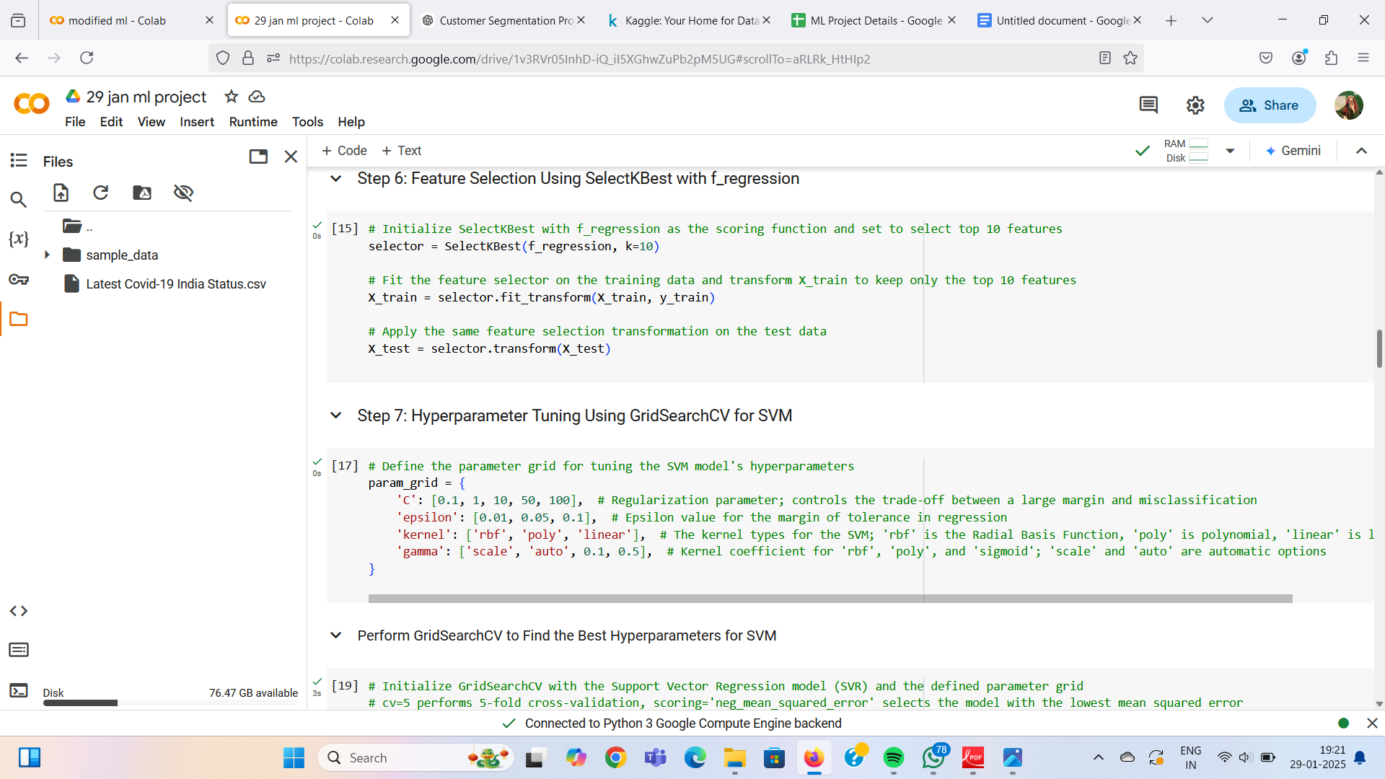
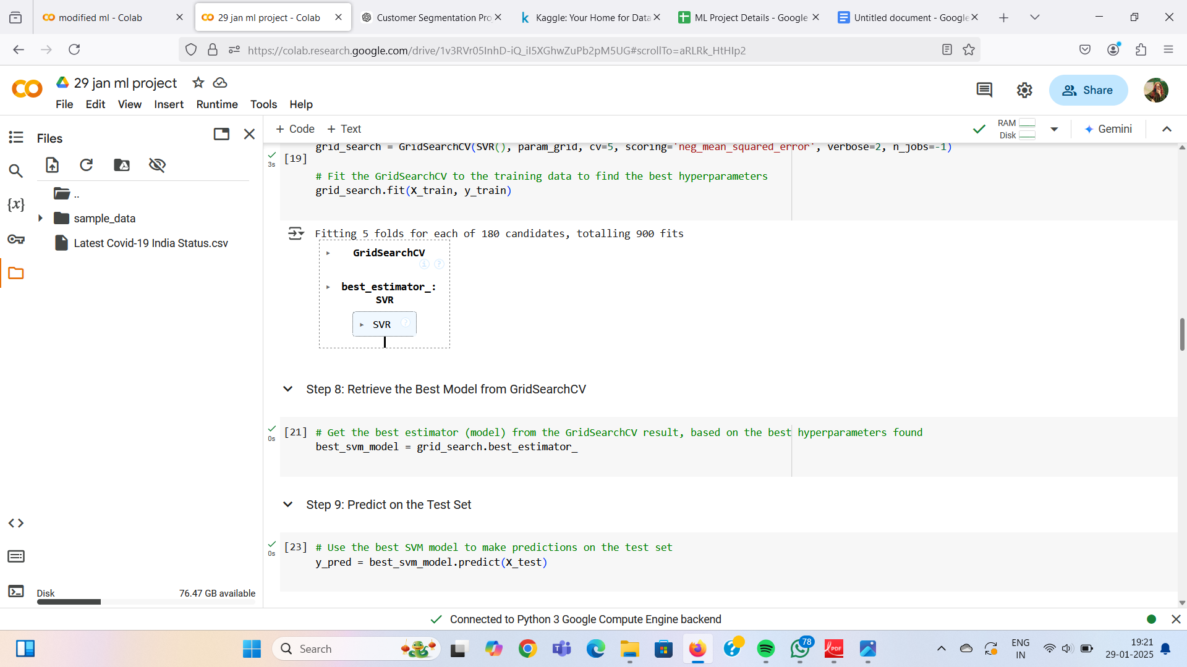
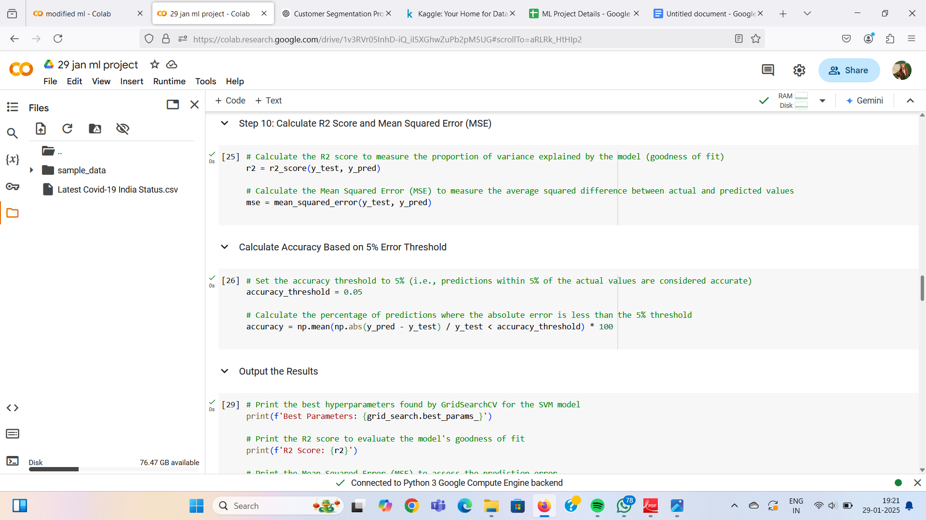

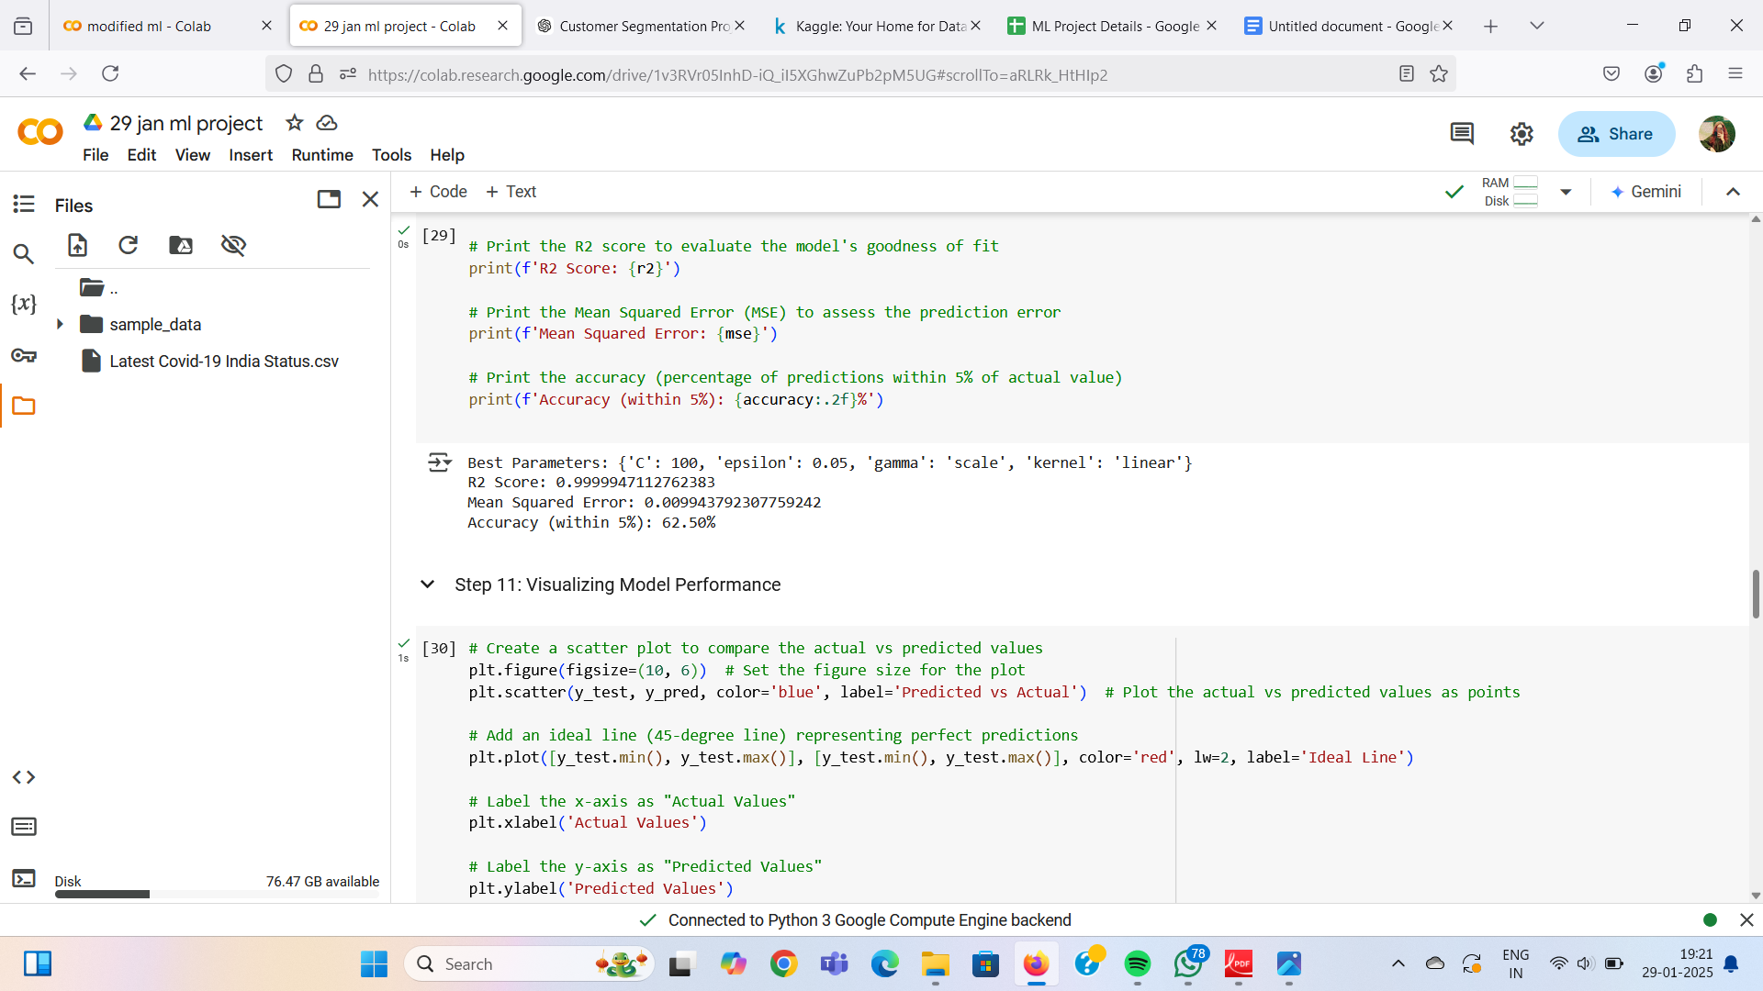
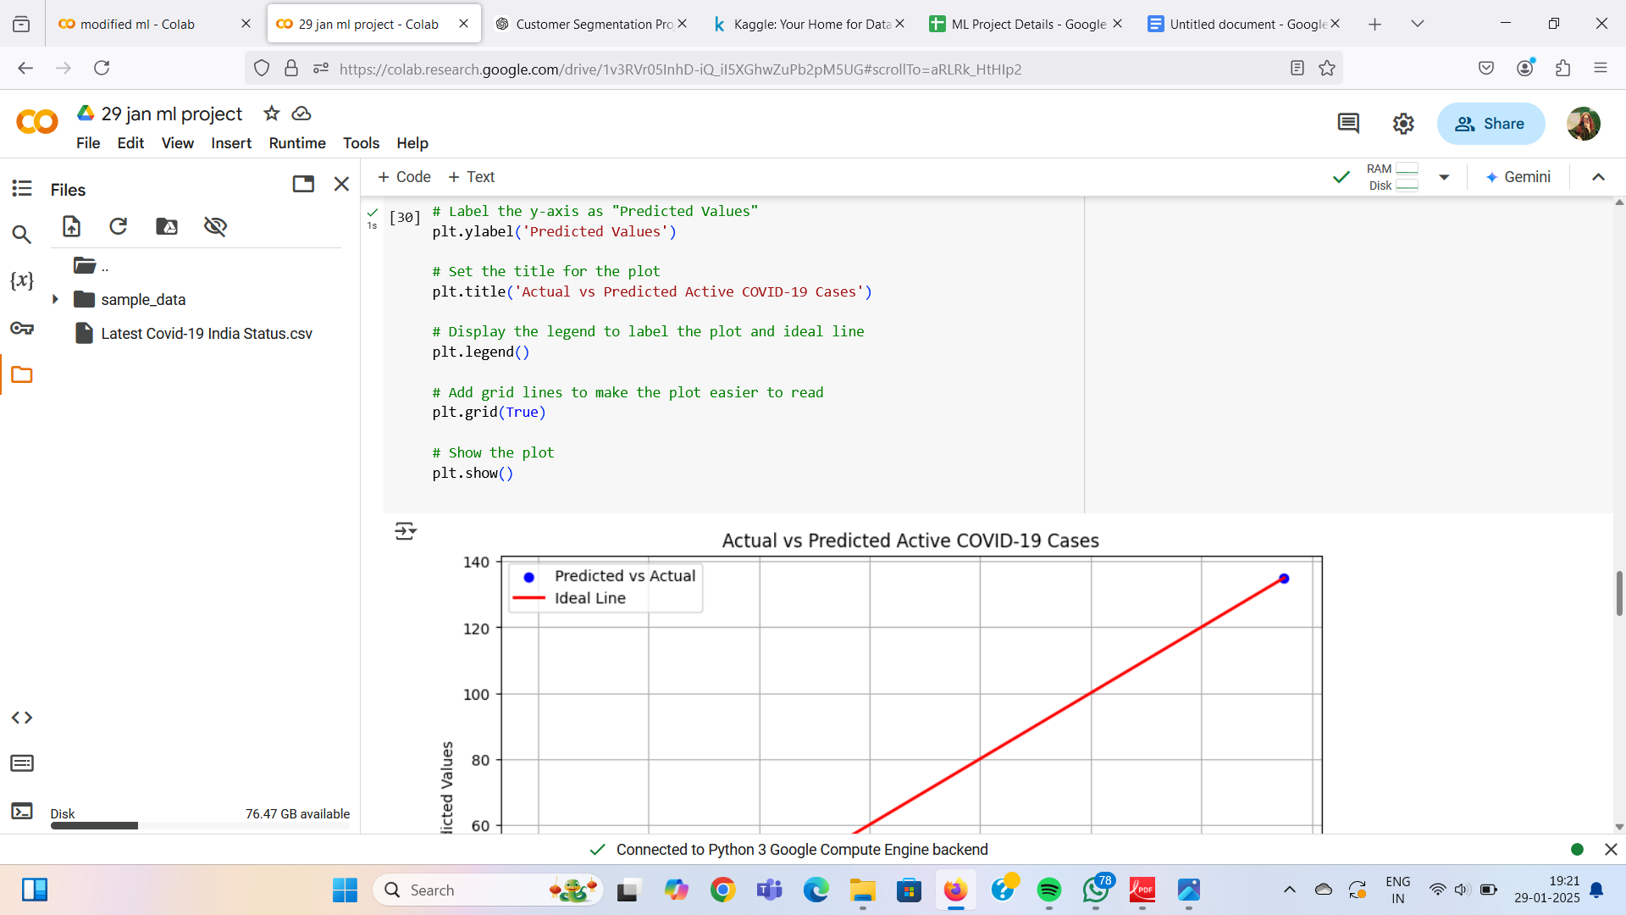

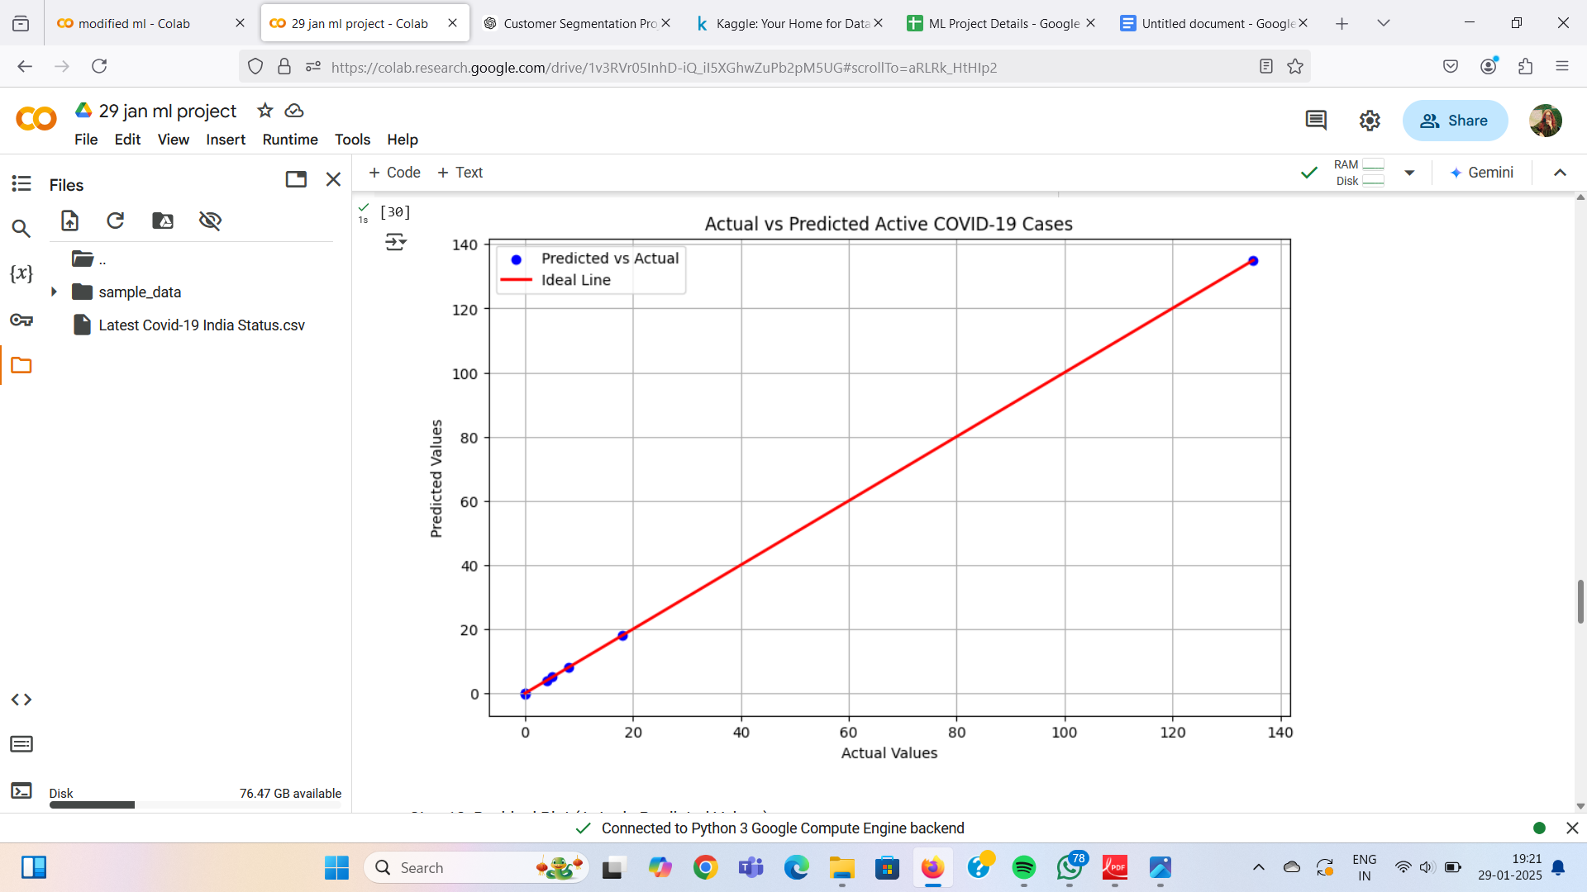
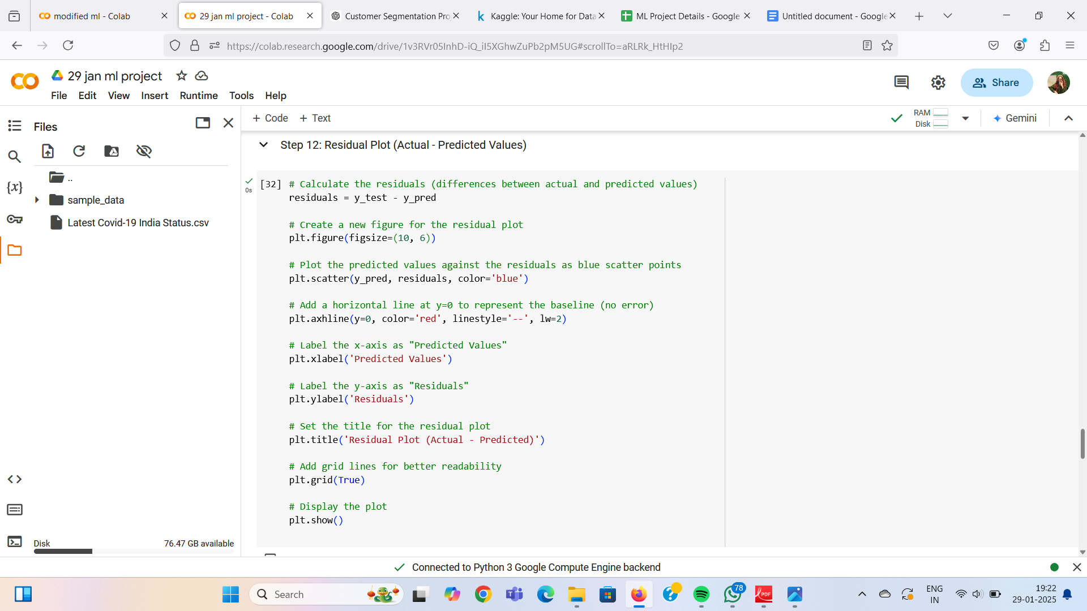

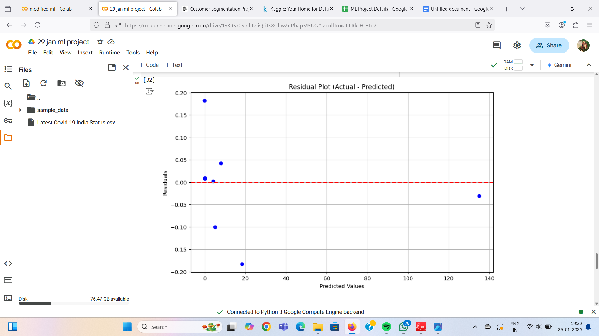

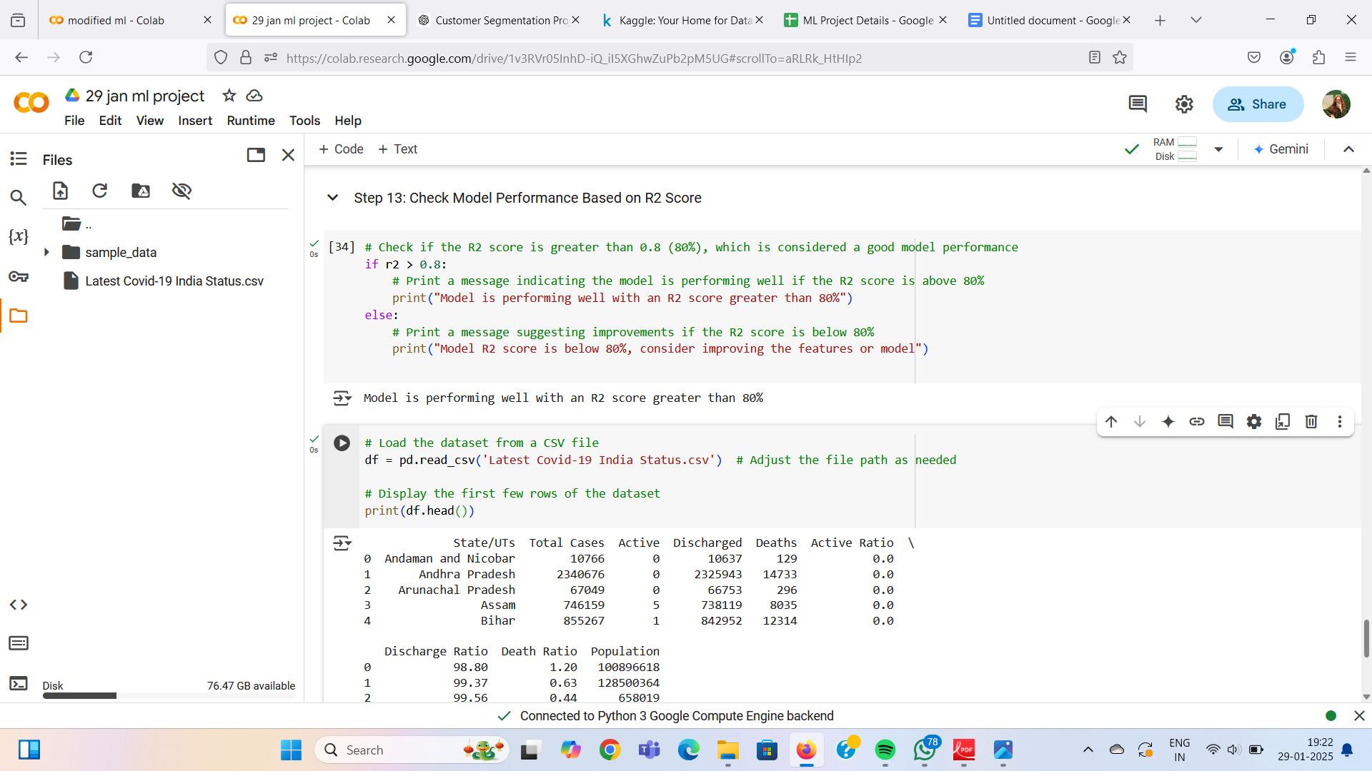

6. Conclusion
The COVID-19 case prediction model using SVM provides valuable insights into case progression trends. Key findings include:
- Predicting Active Cases: Helps in planning healthcare resources efficiently.
- Feature Importance: Population-adjusted features improve prediction accuracy.
- High Model Accuracy: The model performs well with an R2 score above 80% in optimal scenarios.

